Day 5: DevOps

Create GitHub repo:

"Add and commit all files to the remote repository."

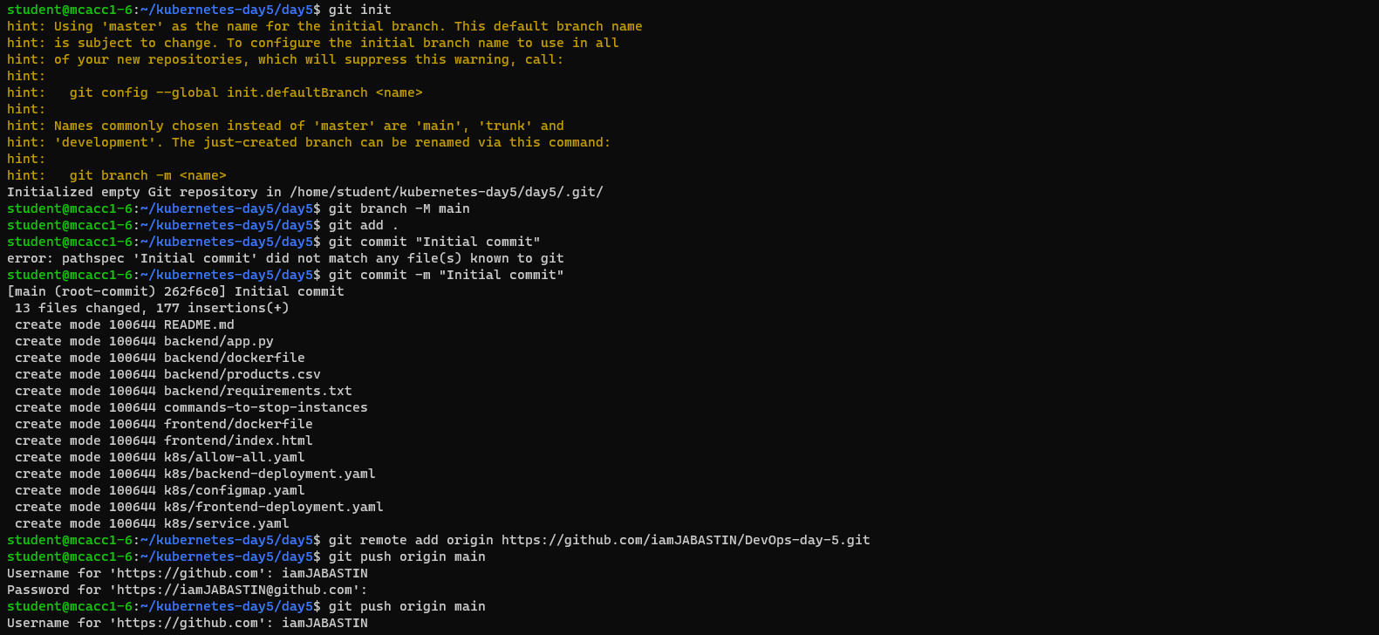

Push local changes to the remote repository

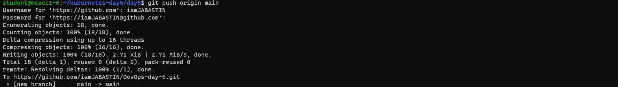

Create a Jenkins config file Jenkinsfile

A Jenkinsfile is a script that defines a Jenkins pipeline. It outlines how Jenkins should build, test, and deploy your code. Instead of manually configuring Jenkins jobs through the web interface, you can store the entire pipeline as code in your repository

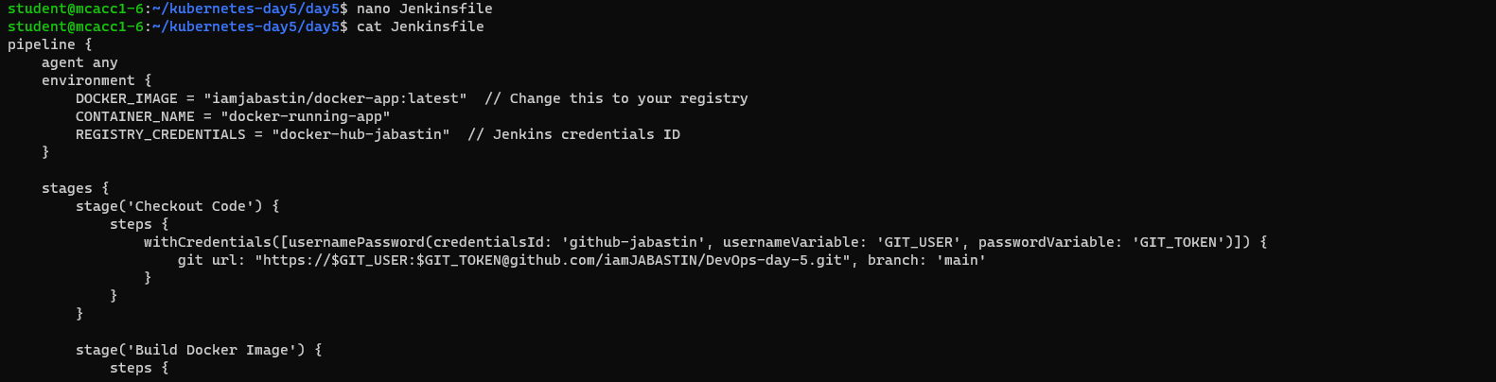

Enable and Start the Jenkins

Vist the Jenkins in Port 8080

Jenkins Pipe Line

Create a Jenkins Pipeline

Push the Jenkins file to the Remote Repo

Install Kubernetes plugin in Jenkins

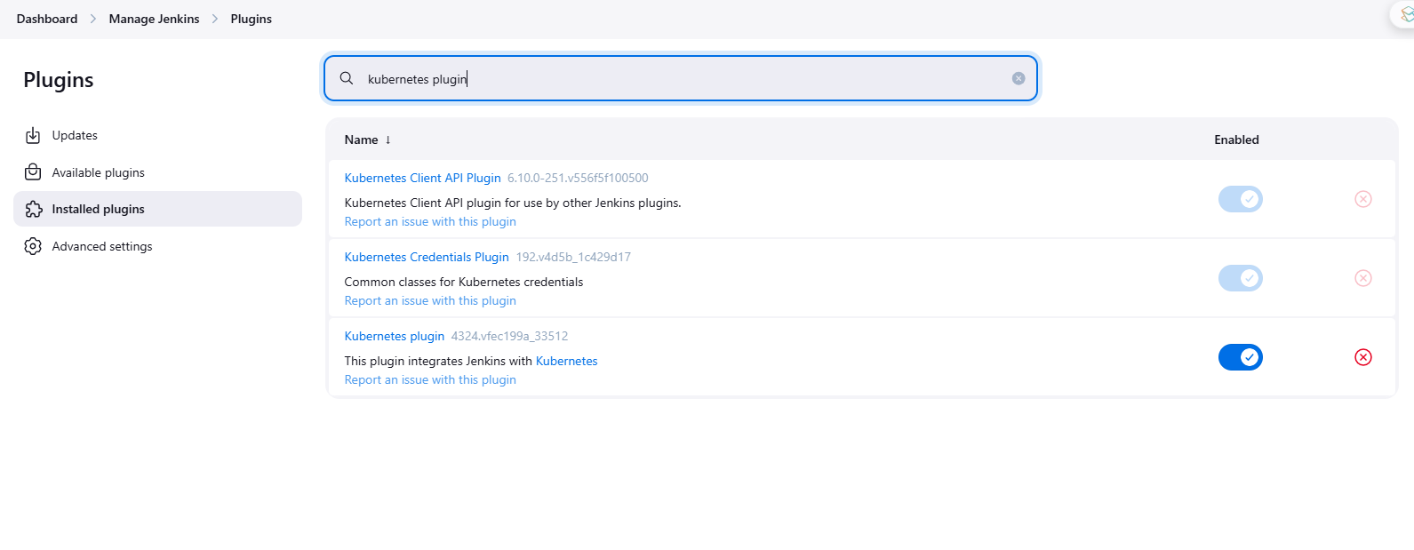

Build the Jenkins

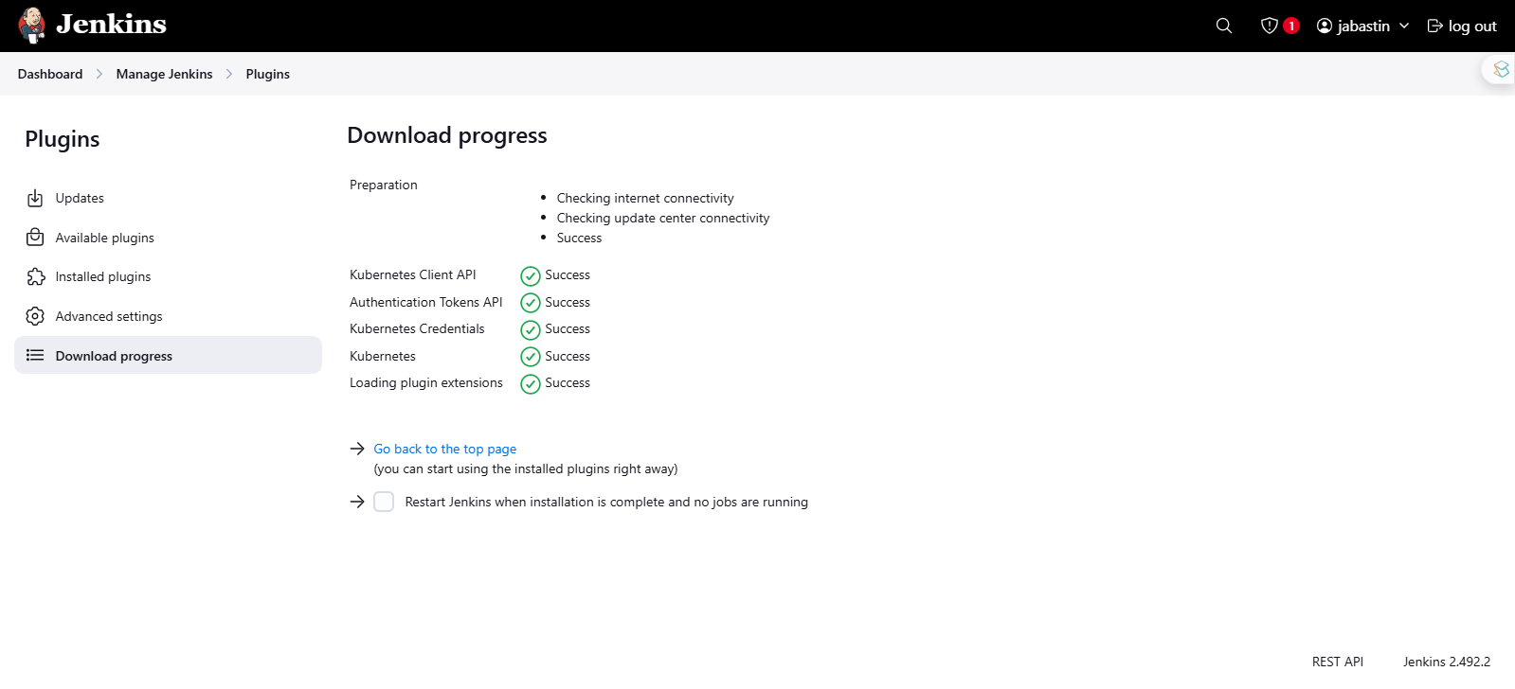

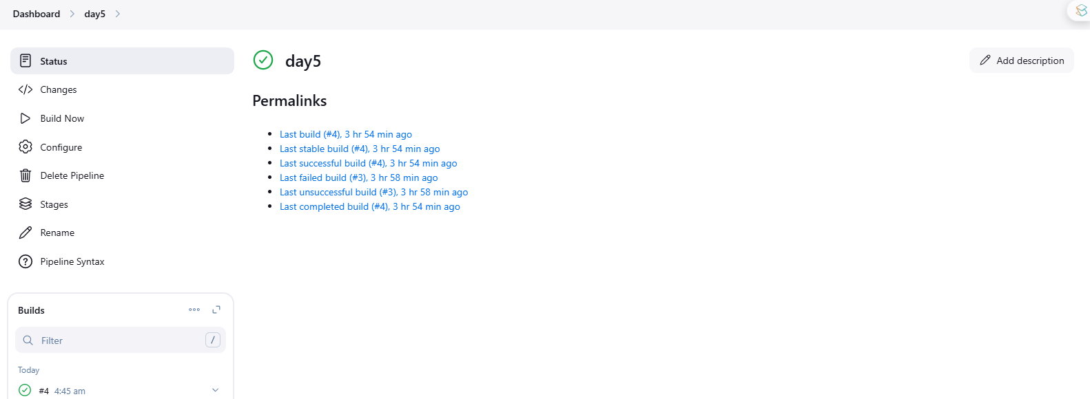

Build successful

To test Frontend

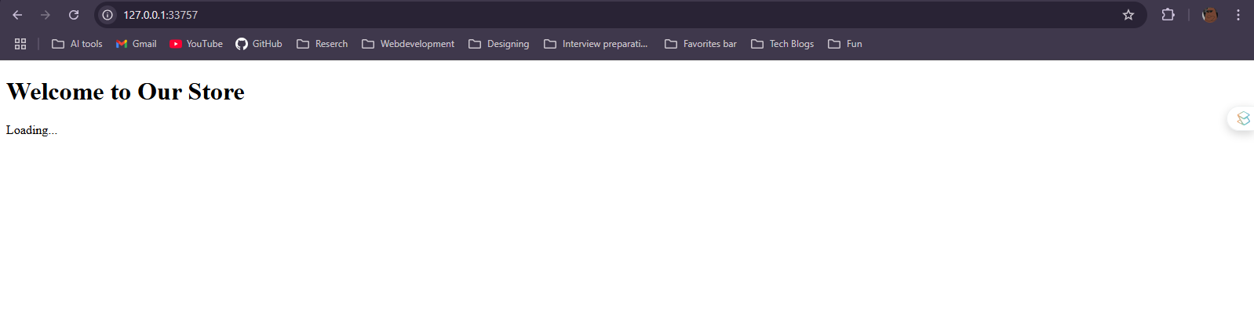

To Test backend

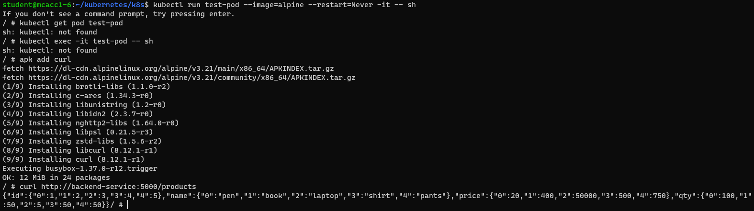

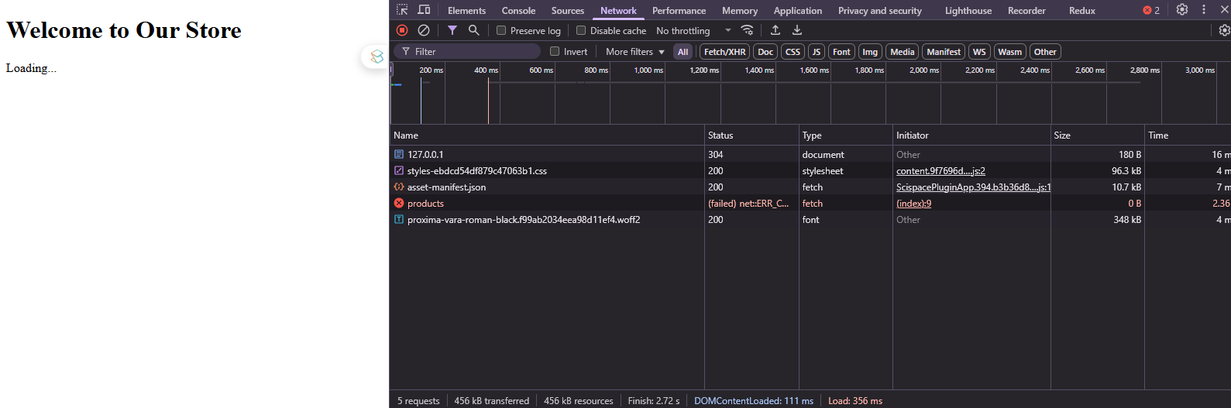

Note: We expect this kind of output because we are running this frontend on localhost.

— COMPLETED —

